What are Scopes?
Scope as Data-Model
$scope as an automated bridge between JavaScript and the DOM itself which holds our synchronised data. This allows us to template easier using handlebars syntax inside the HTML we love, and Angular will render out the associated $scope values. This creates a binding between JavaScript and the DOM, the $scope Object is really a glorified ViewModel.
$rootScope
The $rootScope isn't all that different from $scope, except it is the very top level$scope Object from which all further scopes are created. Once Angular starts rendering your application, it creates a $rootScope Object, and all further bindings and logic in your application create new $scope Objects which then all become children of the $rootScope.
- Scopes provide APIs ($watch) to observe model mutations. The $watch allows the directives to be notified of property changes, which allows the directive to render the updated value to the DOM.
- Scopes provide APIs ($apply) to propagate any model changes through the system into the view from outside of the "Angular realm" (controllers, services, Angular event handlers).

Scope Life Cycle
- Creation
The root scope is created during the application bootstrap by the $injector. During template linking, some directives create new child scopes.
- Watcher registration
During template linking, directives register watches on the scope. These watches will be used to propagate model values to the DOM.
- Model mutation
For mutations to be properly observed, you should make them only within the scope.$apply(). Angular APIs do this implicitly, so no extra $apply call is needed when doing synchronous work in controllers, or asynchronous work with $http, $timeout or $intervalservices.
- Mutation observation
At the end of $apply, Angular performs a $digest cycle on the root scope, which then propagates throughout all child scopes. During the $digest cycle, all $watched expressions or functions are checked for model mutation and if a mutation is detected, the$watch listener is called.
- Scope destruction
When child scopes are no longer needed, it is the responsibility of the child scope creator to destroy them via scope.$destroy() API. This will stop propagation of $digest calls into the child scope and allow for memory used by the child scope models to be reclaimed by the garbage collector.

Scope Hierarchies
.show-scope-demo.ng-scope,
.show-scope-demo .ng-scope {
border: 1px solid red;
margin: 3px;
}

angular.module('scopeExample', [])
.controller('GreetController', ['$scope', '$rootScope', function($scope, $rootScope) {
$scope.name = 'World';
$rootScope.department = 'Angular';
}])
.controller('ListController', ['$scope', function($scope) {
$scope.names = ['Igor', 'Misko', 'Vojta'];
}]);

<div class="show-scope-demo">
<div ng-controller="GreetController">
Hello {{name}}!
</div>
<div ng-controller="ListController">
<ol>
<li ng-repeat="name in names">{{name}} from {{department}}</li>
</ol>
</div>
</div>

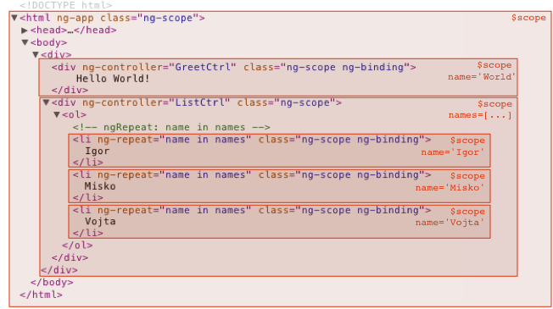

Scope Events Propagation

<div ng-controller="EventController">
Root scope <tt>MyEvent</tt> count: {{count}}
<ul>
<li ng-repeat="i in [1]" ng-controller="EventController">
<button ng-click="$emit('MyEvent')">$emit('MyEvent')</button>
<button ng-click="$broadcast('MyEvent')">$broadcast('MyEvent')</button>
<br>
Middle scope <tt>MyEvent</tt> count: {{count}}
<ul>
<li ng-repeat="item in [1, 2]" ng-controller="EventController">
Leaf scope <tt>MyEvent</tt> count: {{count}}
</li>
</ul>
</li>
</ul>
</div>

angular.module('eventExample', [])
.controller('EventController', ['$scope', function($scope) {
$scope.count = 0;
$scope.$on('MyEvent', function() {
$scope.count++;
});
}]);

Here is the explanation of how the Hello world example achieves the data-binding effect when the user enters text into the text field.
- During the compilation phase:
  - the ng-model and input directive set up a keydown listener on the <input> control.
  - the interpolation sets up a $watch to be notified of name changes.
- During the runtime phase:
  - Pressing an 'X' key causes the browser to emit a keydown event on the input control.
  - The input directive captures the change to the input's value and calls $apply("name = 'X';") to update the application model inside the Angular execution context.
  - Angular applies the name = 'X'; to the model.
  - The $digest loop begins
  - The $watch list detects a change on the name property and notifies the interpolation, which in turn updates the DOM.
  - Angular exits the execution context, which in turn exits the keydown event and with it the JavaScript execution context.
  - The browser re-renders the view with the updated text.
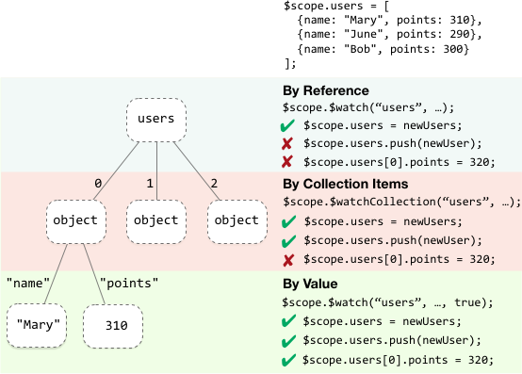

What are Services?
Services are where we would create to hold our application's Model data and business logic such as talking to the server over HTTP. There is often a lot of confusion between a Service and Factory, the main difference is the way each Object is created.

Angular services are:
Lazily instantiated – Angular only instantiates a service when an application component depends on it.
Singletons – Each component dependent on a service gets a reference to the single instance generated by the service factory.

Service method
Angular gives us a service method for creating a new Object with, this could talk to a backend or provide utilities to handle business logic. A service is just aconstructor Object that gets called with the new keyword, which means we'll be using the this keyword to bind our logic to the Service. The service creates a singleton Object created by a service factory.

function UserService () {
this.sayHello = function (name) {
return 'Hello there ' + name;
};
}

angular
.module('app')
.service('UserService', UserService);

function MainCtrl (UserService) {
this.sayHello = function (name) {
UserService.sayHello(name);
};
}

angular
.module('app')
.controller('MainCtrl', MainCtrl);

Factory method
Factory methods return an Object or a Function, which means we can make usage of closures as well as returning a host Object to bind methods to. We can create private and public scope. All Factories become a Service, to we should refer to them as a Service not the pattern they are named after.
function UserService () {
var UserService = {};
function greeting (name) {
return 'Hello there ' + name;
}
UserService.sayHello = function (name) {
return greeting(name);
};
return UserService;
}

angular
.module('app')
.factory('UserService', UserService);

provider
Here's the source for the provider method:
function provider(name, provider_) {
if (isFunction(provider_) || isArray(provider_)) {
provider_ = providerInjector.instantiate(provider_);
}
if (!provider_.$get) {
throw Error('Provider ' + name + ' must define $get factory method.');
}
return providerCache[name + providerSuffix] = provider_;
}
name is a string. provider_ can be one of three things:
- function
If a function is passed in, the function is called with dependency injection and should return an object with a $get method.
- array
An array will be treated like a function using Inline Annotation. It must also return an object with a $get method.
- object
If an object is passed in, it is simply expected to have a $get method.
Whatever the second arg to provider is, you eventually end up with an object that has a $get method. Here's an example showing what happens:
// You can run this
// Create a module
var hippo = angular.module('hippo', []);
// Register an object provider
hippo.provider('awesome', {
$get: function() {
return 'awesome data';
}
});
// Get the injector (this happens behind the scenes in angular apps)
var injector = angular.injector(['hippo', 'ng']);
// Call a function with dependency injection
injector.invoke(function(awesome) {
console.log('awesome == ' + awesome);
});
Once you understand providers you will see that factory, service, valueand constant are just convenience methods for making providers.

factory
Here's the source:
function factory(name, factoryFn) {
return provider(name, { $get: factoryFn });
}
So it lets you shorten the awesome provider creation code to this:
hippo.factory('awesome', function() {
return 'awesome data';
})

service
Here's the source:
function service(name, constructor) {
return factory(name, ['$injector', function($injector) {
return $injector.instantiate(constructor);
}]);
}
So it lets you make a factory that will instantiate a "class". For example:
var gandalf = angular.module('gandalf', []);
function Gandalf() {
this.color = 'grey';
}
Gandalf.prototype.comeBack = function() {
this.color = 'white';
}
gandalf.service('gandalfService', Gandalf);
var injector = angular.injector(['gandalf', 'ng']);
injector.invoke(function(gandalfService) {
console.log(gandalfService.color);
gandalfService.comeBack()
console.log(gandalfService.color);
});
The above code will instantiate Gandalf, but remember that everything that uses the service will get the same instance! (which is a good thing).

value
Here's the source:
function value(name, value) {
return factory(name, valueFn(value));
}
Using value would let you shorten the awesome provider to:
hippo.value('awesome', 'awesome data');

constant
Here's the source
function constant(name, value) {
providerCache[name] = value;
instanceCache[name] = value;
}
constant differs from value in that it's accessible during config. Here's how you use it:
var joe = angular.module('joe', []);
joe.constant('bobTheConstant', 'a value');
joe.value('samTheValue', 'a different value');
joe.config(function(bobTheConstant) {
console.log(bobTheConstant);
});
joe.config(function(samTheValue) {
console.log(samTheValue);
});
// This will fail with "Error: Unknown provider: samTheValue from joe"
var injector = angular.injector(['joe', 'ng']);

In summary
If you want your function to be called like a normal function, use factory. If you want your function to be instantiated with the new operator, useservice. If you don't know the difference, use factory.
This is the (great) documentation for each function in the AngularJS source:
- factory
A short hand for configuring services if only `$get` method is required.
- service
A short hand for registering service of given class.
- value
A short hand for configuring services if the `$get` method is a constant.
- constant
A constant value, but unlike {@link AUTO.$provide#value value} it can be injected into configuration function (other modules) and it is not interceptable by {@link AUTO.$provide#decorator decorator}.

Factory

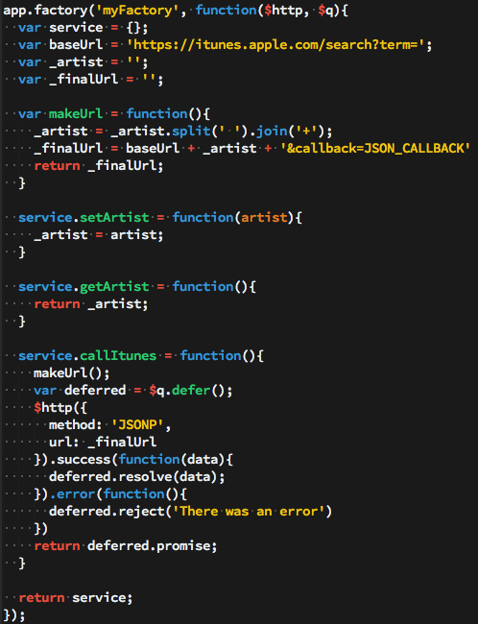

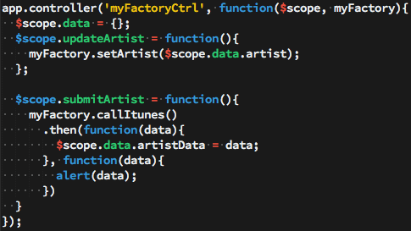

Service

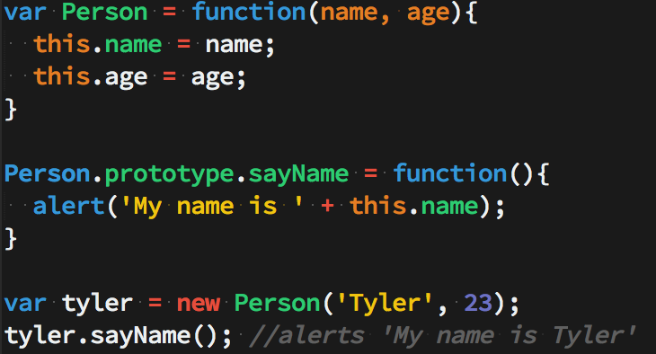

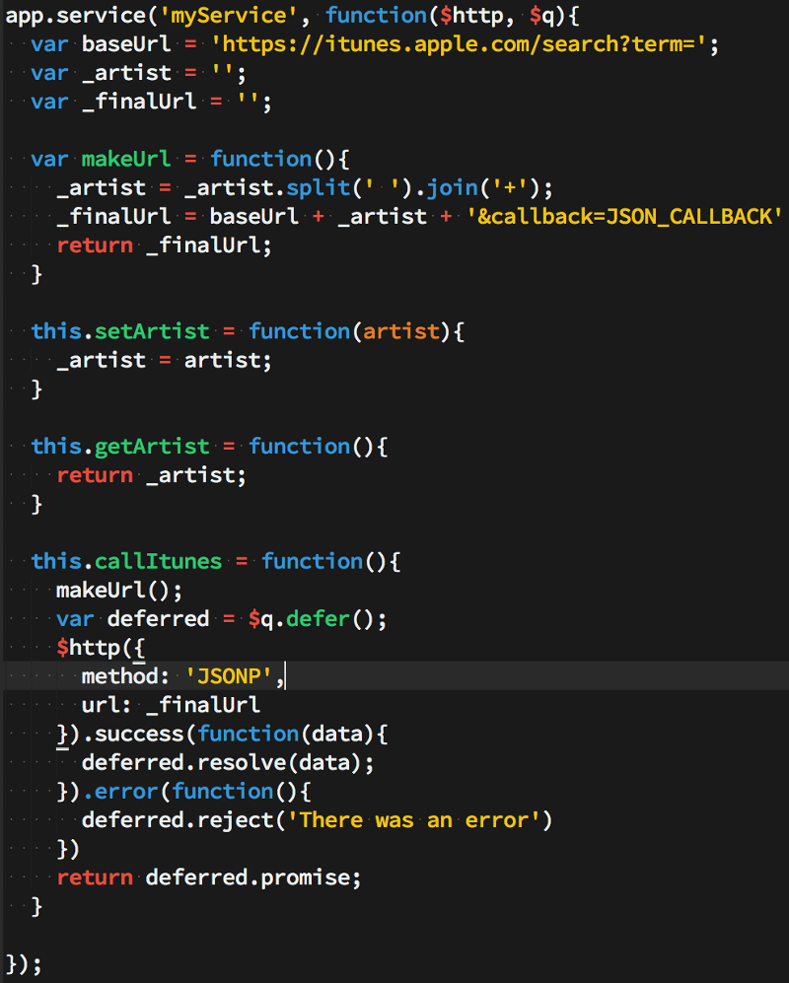

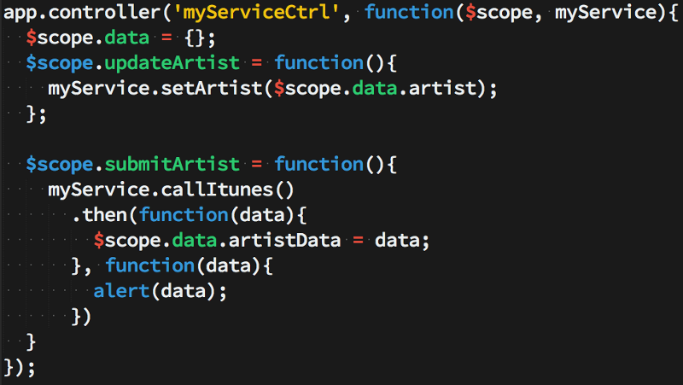

Provider

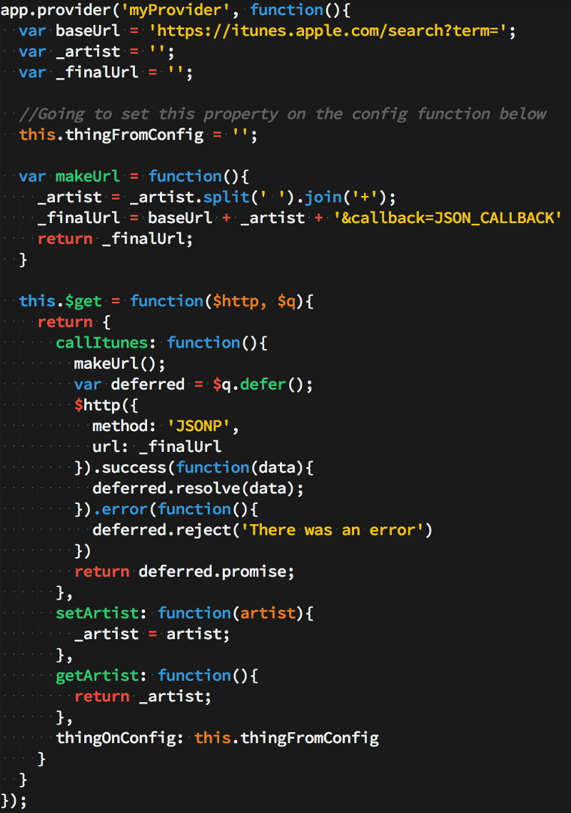

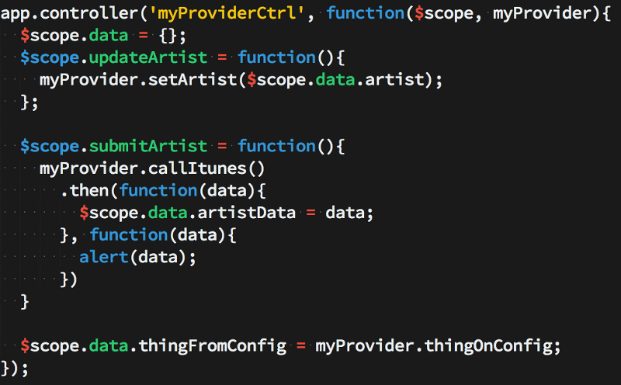

Predefined Services
$http
// Simple GET request example:
$http({
method: 'GET',
url: '/someUrl'
}).then(function successCallback(response) {
// this callback will be called asynchronously
// when the response is available
}, function errorCallback(response) {
// called asynchronously if an error occurs
// or server returns response with an error status.
});

The response object has these properties:
- data – {string|Object} – The response body transformed with the transform functions.
- status – {number} – HTTP status code of the response.
- headers – {function([headerName])} – Header getter function.
- config – {Object} – The configuration object that was used to generate the request.
- statusText – {string} – HTTP status text of the response.

Shortcut methods
$http.get('/someUrl', config).then(successCallback, errorCallback);
$http.post('/someUrl', data, config).then(successCallback, errorCallback);

Caching
$http responses are not cached by default. To enable caching, you must set the config.cache value or the default cache value to TRUE or to a cache object (created with $cacheFactory). If defined, the value of config.cache takes precedence over the default cache value.
In order to:
- cache all responses - set the default cache value to TRUE or to a cache object
- cache a specific response - set config.cache value to TRUE or to a cache object
The default cache value can be set by updating the $http.defaults.cache property or the $httpProvider.defaults.cache property.
Take note that:
- Only GET and JSONP requests are cached.
- The cache key is the request URL including search parameters; headers are not considered.
- Cached responses are returned asynchronously, in the same way as responses from the server.
- If multiple identical requests are made using the same cache, which is not yet populated, one request will be made to the server and remaining requests will return the same response.
- A cache-control header on the response does not affect if or how responses are cached.

get(url, [config]);
delete(url, [config]);
head(url, [config]);
jsonp(url, [config]);
post(url, data, [config]);
put(url, data, [config]);
patch(url, data, [config]);

index.html
<div ng-controller="FetchController">
<select ng-model="method" aria-label="Request method">
<option>GET</option>
<option>JSONP</option>
</select>
<input type="text" ng-model="url" size="80" aria-label="URL" />
<button id="fetchbtn" ng-click="fetch()">fetch</button><br>
<button id="samplegetbtn" ng-click="updateModel('GET', 'http-hello.html')">Sample GET</button>
<button id="samplejsonpbtn"
ng-click="updateModel('JSONP',
'https://angularjs.org/greet.php?callback=JSON_CALLBACK&name=Super%20Hero')">
Sample JSONP
</button>
<button id="invalidjsonpbtn"
ng-click="updateModel('JSONP', 'https://angularjs.org/doesntexist&callback=JSON_CALLBACK')">
Invalid JSONP
</button>
<pre>http status code: {{status}}</pre>
<pre>http response data: {{data}}</pre>
</div>

Script.js
angular.module('httpExample', [])
.controller('FetchController', ['$scope', '$http', '$templateCache',
function($scope, $http, $templateCache) {
$scope.method = 'GET';
$scope.url = 'http-hello.html';

$scope.fetch = function() {
$scope.code = null;
$scope.response = null;

$http({method: $scope.method, url: $scope.url, cache: $templateCache}).
then(function(response) {
$scope.status = response.status;
$scope.data = response.data;
}, function(response) {
$scope.data = response.data || 'Request failed';
$scope.status = response.status;
});
};

$scope.updateModel = function(method, url) {
$scope.method = method;
$scope.url = url;
};
}]);
http.hello.html
Hello, $http!

